Project 4 – Milestone Screenshots
Table of Contents
Pipeline Created, Console View 1
Connected AWS to GitHub 2
First Successful Deployment – Test Run 3
Test – Editing Site Description 4
Manual Edit 4
Manual Commit/Push to Github 5
Successful Deployment in AWS Pipeline 5
Site Updated Successfully 6

Pipeline Created, Console View
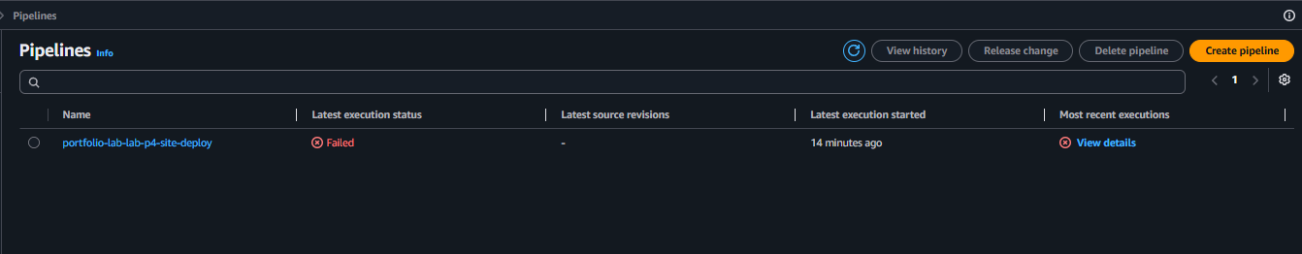
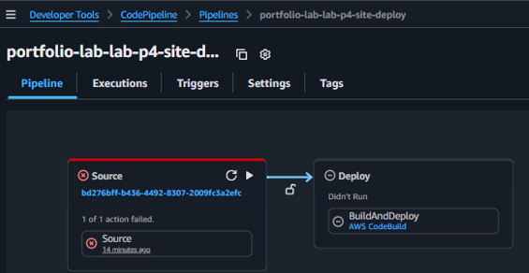
- Failed before AWS was connected to GitHub

Connected AWS to GitHub
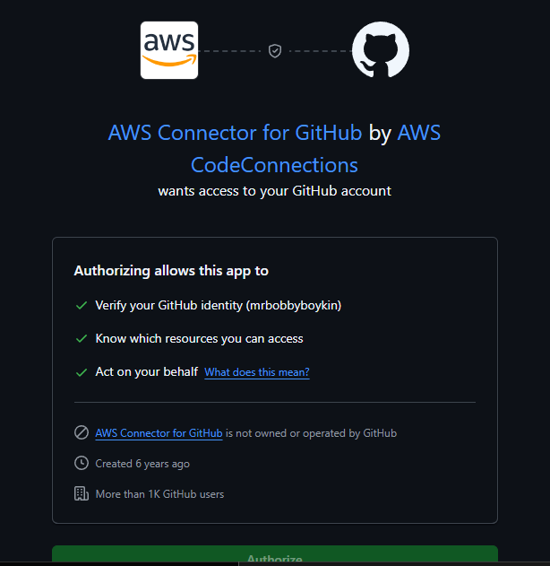
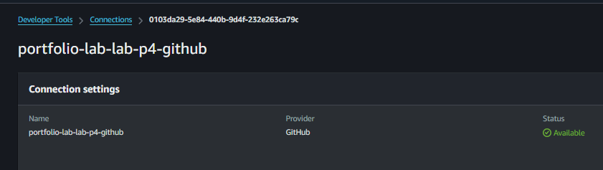

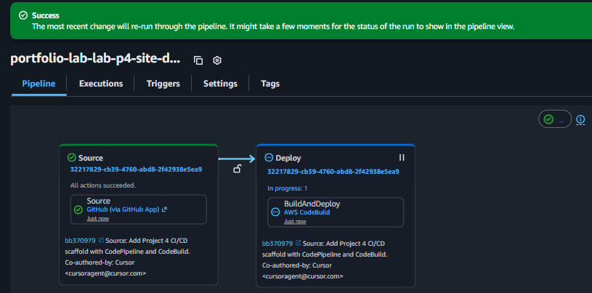

First Successful Deployment – Test Run
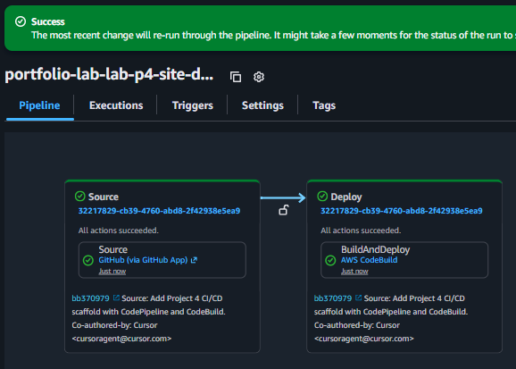

Test – Editing Site Description
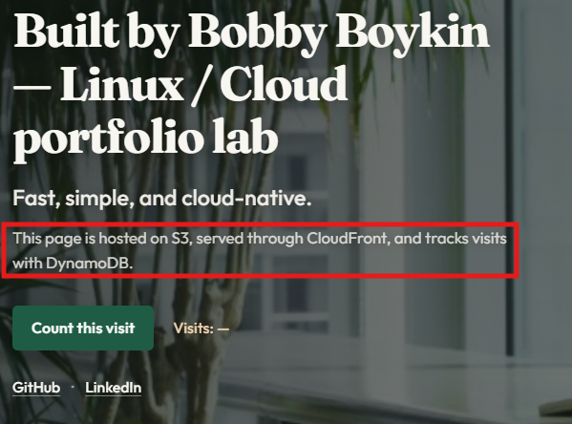

Manual Edit
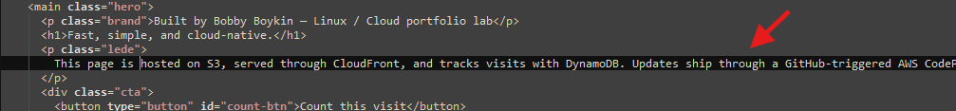

Manual Commit/Push to Github
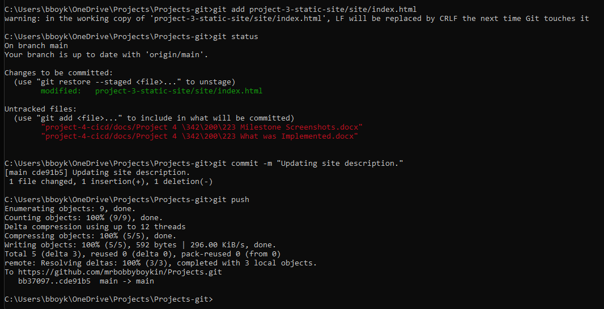

Successful Deployment in AWS Pipeline
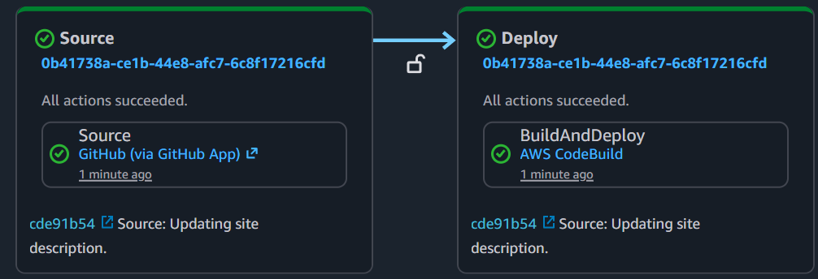

Site Updated Successfully
